
University of New York, Tirana

M.Sc. in Computer Science
Distributed Systems

DEVELOPMENT OF A DISTRIBUTED OBJECT BASED SYSTEM BASED ON ENTERPRISE JAVA BEANS

Host:
Department of Computer Science
School of Computing and Mathematical Sciences
University of Greenwich

Partner:
University of New York in Tirana

Student: Xhentilo Karaj

Content
1. Architecture 3
2. Design of the components 4
3. Implementation 6
4. Test 7
Bibliography 19

Architecture
The Java EE platform uses a distributed multi-tiered application model for enterprise applications. Application logic is divided into components according to function, and the application components that make up a Java EE application may be installed on various machines, depending on the tier in the multi-tiered Java EE environment to which the application component belongs (Oracle Corporation, 2014).

The Java EE application that has been developed for the purpose of this coursework is composed of the following components:
- Web Interface tier has been implemented by two Java servlets:
  - SalesUser is a servlet that dynamically processes requests from the web client and constructs the response. It reads the input parameters from the web browser, validates the parameter values and sends the HTTP request to SalesServlet. Afterwards, it reads the response and correctly displays it to the client.
  - SalesServlet is a servlet that accepts HTTP requests from other servlets, processes the requests and returns a response to its clients. It needs to communicate with the database classes, in order to retrieve the necessary information that has been requested by the client, at the MySQL database.
- Processing tier has been implemented by using Enterprise Java Beans, which are business components that run on the Java EE server.
  - SalesServlet uses EntityManagerFactory EJB, which provides an efficient way to construct EntityManager interfaces for a specific database. EntityManagerFactory is an entity bean, which represents persistent data storage. User data can be retrieved from the database by using this particular entity bean (Oracle Corporation, 2017).
- Database tier is represented by the MySQL RDBMS. In order to model the MySQL tables, there have been added two relevant Entity Classes, Products and Sales.

Design of the components
SalesUser servlet class has the following methods and attributes:
- doGet is an overloaded void method that handles the HTTP GET method.
  - It takes two input parameters: the HTTP servlet request and the HTTP servlet response.
  - A PrintWriter object is instantiated in order to print formatted representations of objects to a text-output stream. Obviously, the input data should be transmitted to the server as text data.
  - By using the println method of PrintWriter, the doGet method constructs the Sales User Page in HTML format. Each HTML input field is given a suitable input type and input name in order to identify it when passing to the server.
  - For each request parameter defined above, there is created a respective variable of type String:
    - productid is the id of the product for which the client wants to know the available amount
    - productcountsls is the id of the product for which the client wants to know the number of total sales
    - productcountmonth is the id of the product for which the client wants to know the total sales over the last month
    - mindate and maxdate contain the date range for which the client wants to know the total amount of sales
  - After checking each input parameter for validity, the method instantiates a RequestDispatcher which dispatches the request to the SalesServlet class.
  - include method of RequestDispatcher is used to include the content returned from the SalesServlet.

SalesServlet class contains the following methods and attributes:
- An EntityManagerFactory EJB is defined in order to manage communication with the persistent data storage.
- doGet is an overloaded void method that handles the HTTP GET method.
  - As in the case of the doGet method of SalesUser, it has the same input parameters and instantiates a PrintWriter object as well.
  - By using the getParameter method of the HTTP Servlet Request, the method reads the input parameters and assigns their values to its own attributes.
  - For each of the request parameters, the method performs the following actions:
    - It creates an Entity Manager instance and then calls the createNamedQuery method which returns a new query instance. The latter method gets as input parameter the named query that we would like to execute, i.e. Sales.findAll is used to get all Sales records.
    - A List is created by retrieving the result list of the above query by using its getResultList method.
    - Each list element is retrieved by using the get method of the List interface. In order to retrieve entity attributes, the respective getter method is called upon the get method of the List.
    - The result gets formatted in HTML and it is returned to the client in the form of an HTTP response.

The Entity classes, Products and Sales, contain the following methods and attributes:
- List of named queries that can be used from client classes in order to retrieve data about the entity.
- Class attributes, that correspond to database table column names with the appropriate Java variable data types.
- Empty Constructors.
- Getter and setter methods for all class attributes.
- toString overloaded method.

Implementation

Software used for development and testing of this Java EE application:
- Java SE Development Kit 8 Update 191 (64-bit)
- GlassFish Server Open Source Edition 4.1.1
- NetBeans IDE 8.2
- MySQL Server 5.5.62
  - MySQL Workbench 6.0.9

System Software used:
- Operating System: Windows 7 Home Premium 64-bit

Hardware used:
- Processor: Intel Core i7-2630QM @ 2.00GHz (8 CPUs)
- 4GB RAM
- System Manufacturer: Samsung Electronics Co., Ltd.

Test

Question 1: Display number of available units for a certain product in the database

Test Case 1: Input a product with a positive available amount.
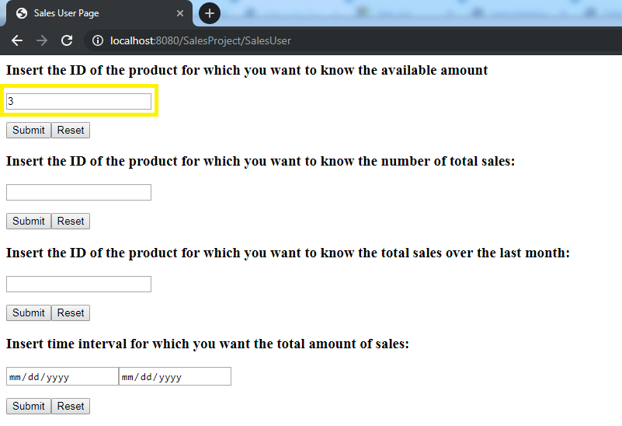

The result is given below:
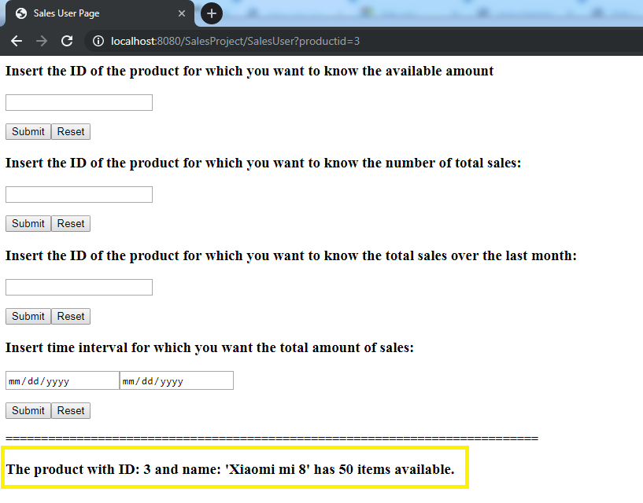

The correct result is matched to the one returned from a direct query in MySQL DB:
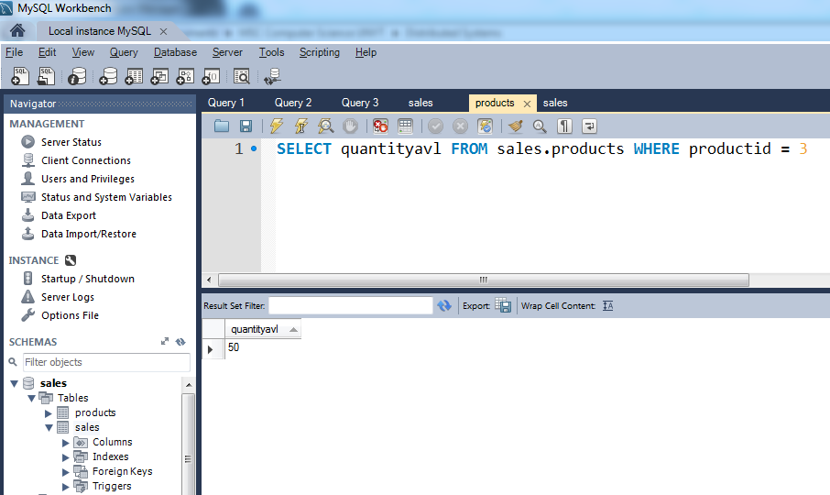

Test Case 2: Input a product with null available amount.
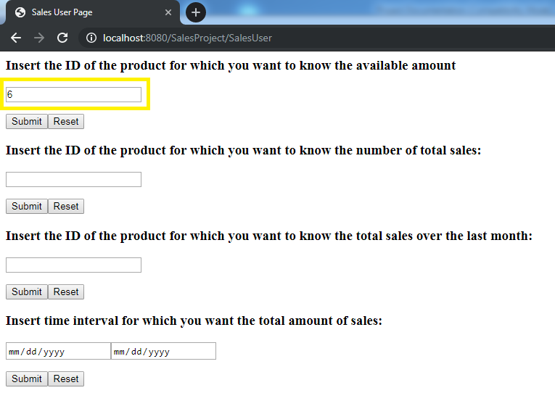

The output is given below:
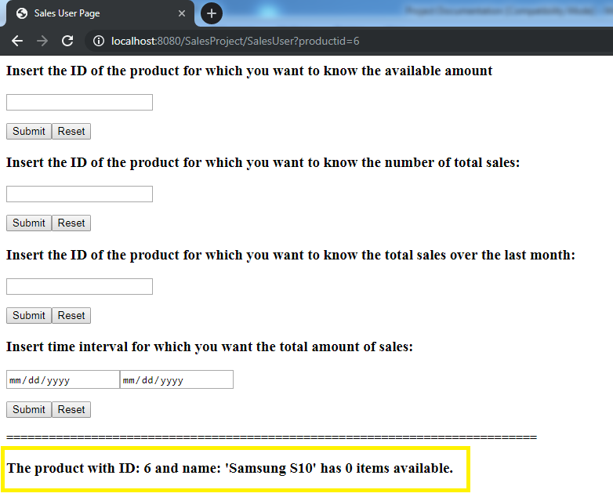

The correct result is matched to the one returned from a direct query in MySQL DB:
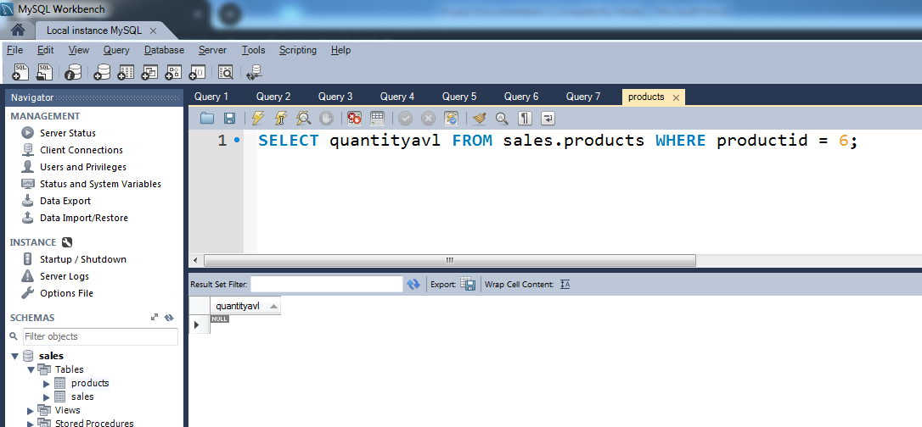

Question 2: Display number of total sales for a certain product in the database.

Test Case 3: Input a product with positive number of total sales.
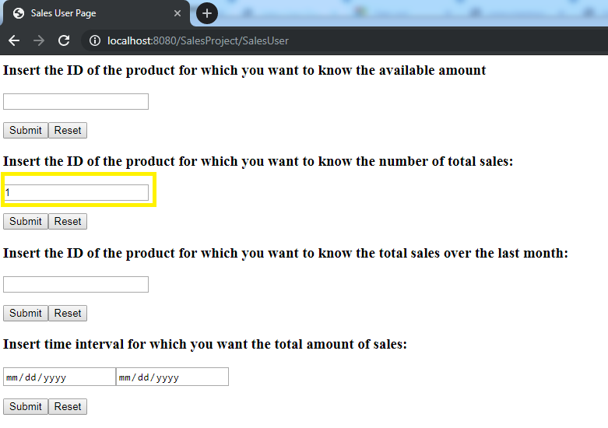

The output is given below:
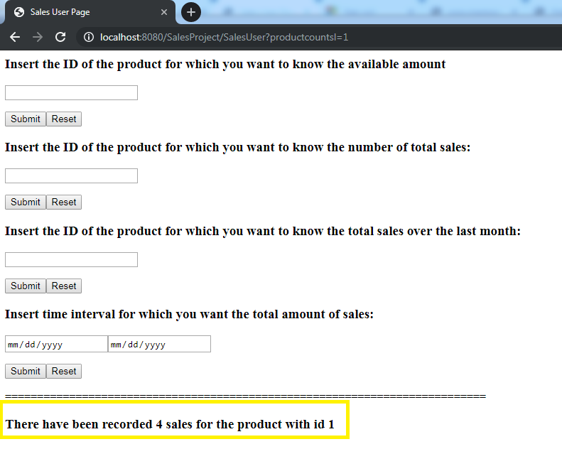
The correct result is matched to the one returned from a direct query in MySQL DB:
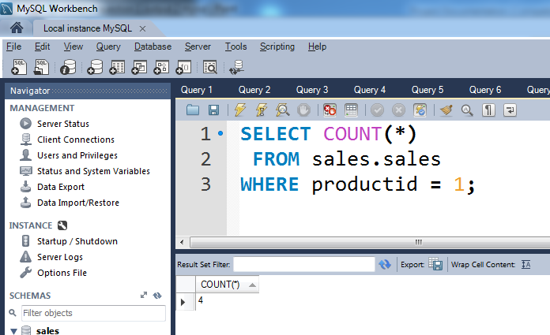

Test Case 4: Input a product for which there have been recorded no sales.
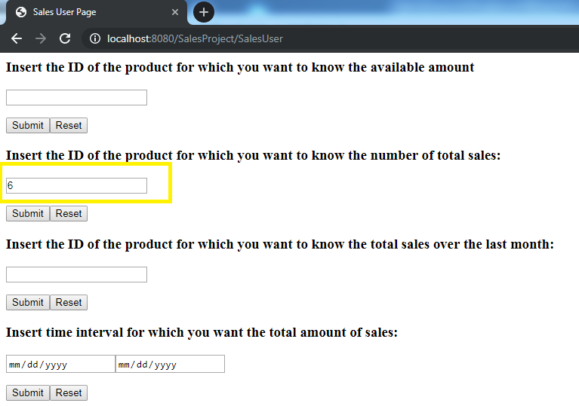

The output is shown below:
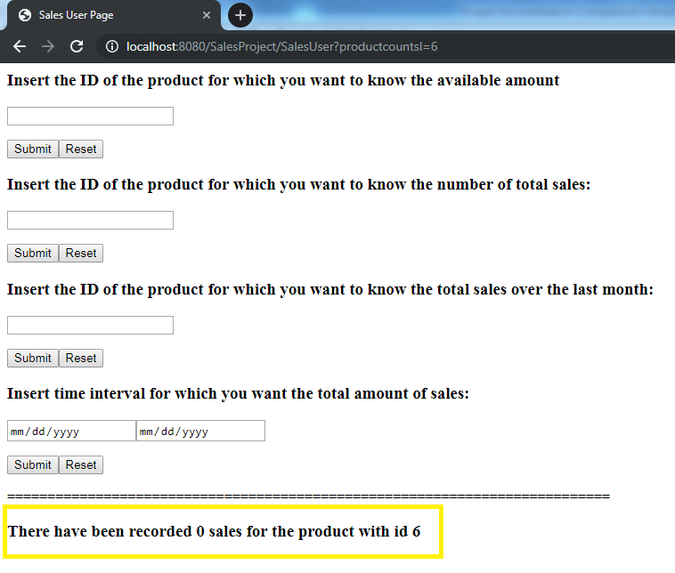

The correct result is matched to the one returned from a direct query in MySQL DB:
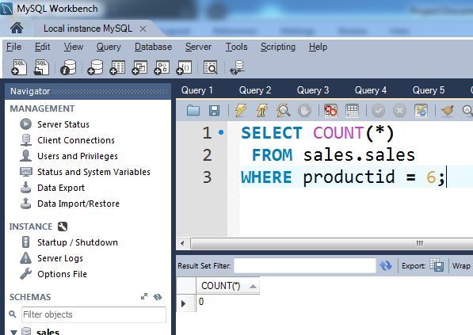
Question 3: Display number of total sales over the last month for a certain product in the database

Test Case 5: Input a product for which there have been recorded sales.
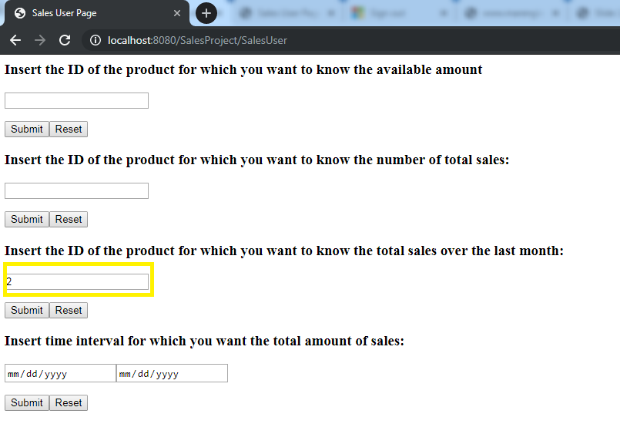

The result is shown below:
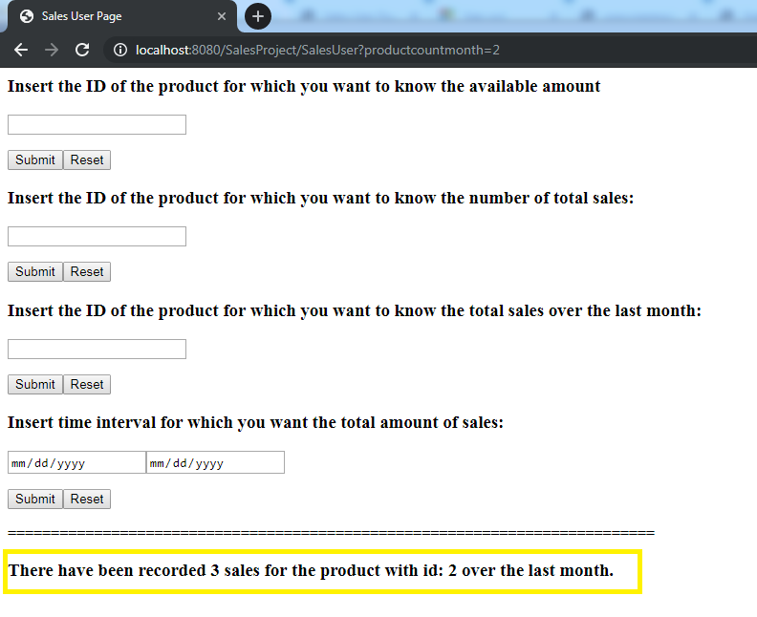

The correct result is matched to the one returned from a direct query in MySQL DB:
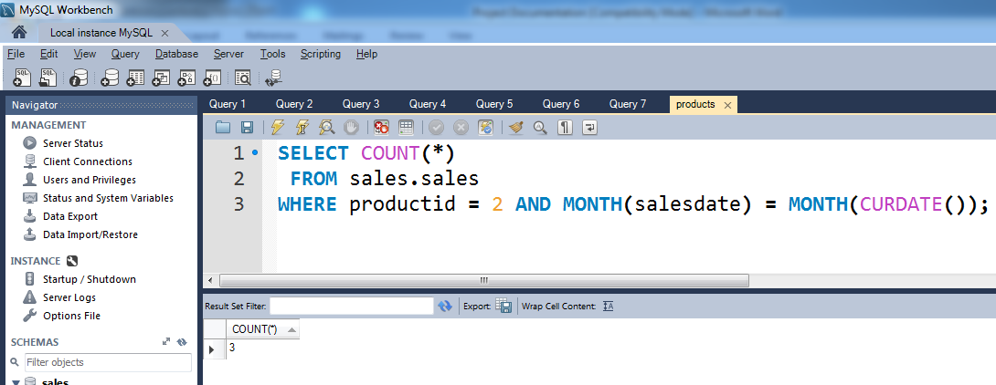

Test Case 6: Input a product for which there have been recorded no sales.
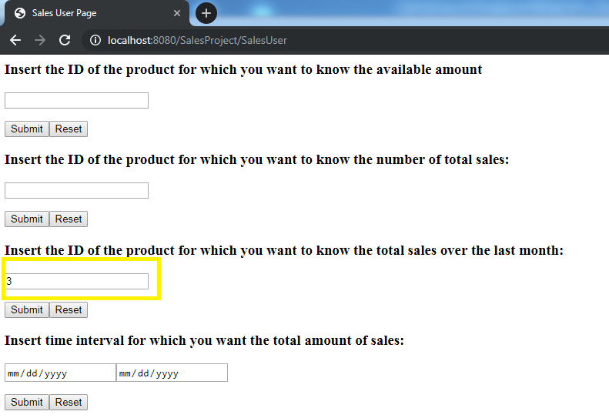

The output is shown below:
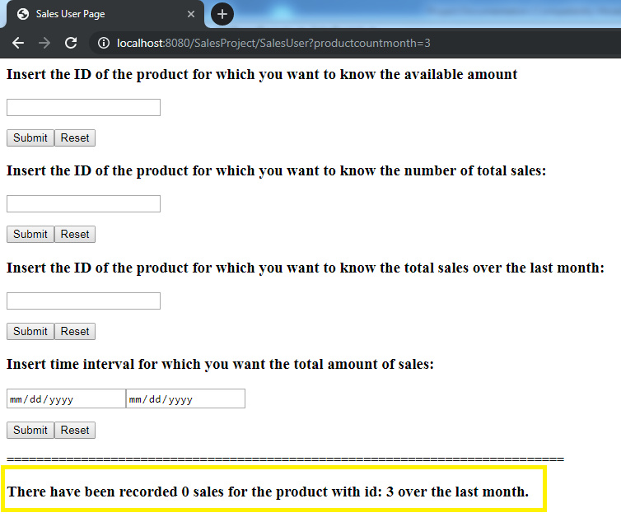

The correct result is matched to the one returned from a direct query in MySQL DB:

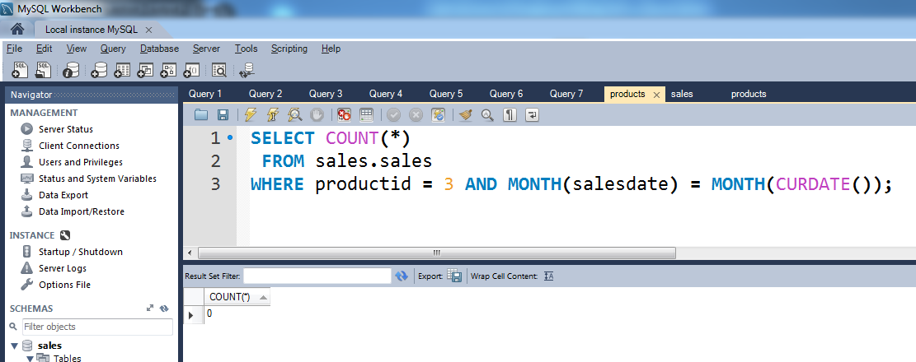

Question 4: Display total amount of sales in a specified period of time.

Test Case 7: Select date range for which the total amount of sales is positive.
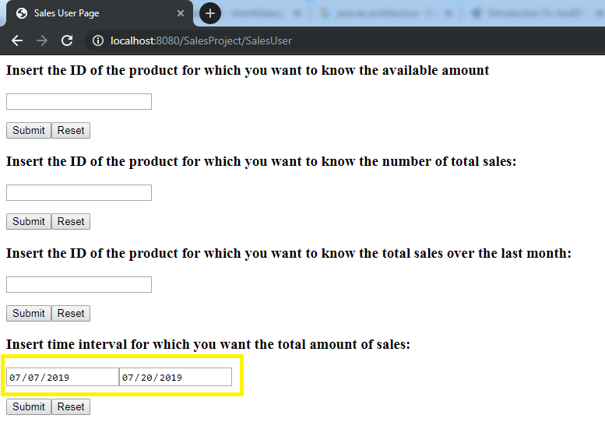

The output is shown below:
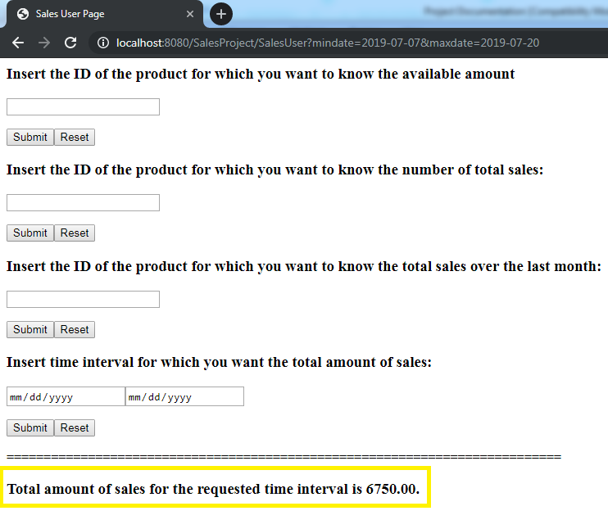
The correct result is matched to the one returned from a direct query in MySQL DB:
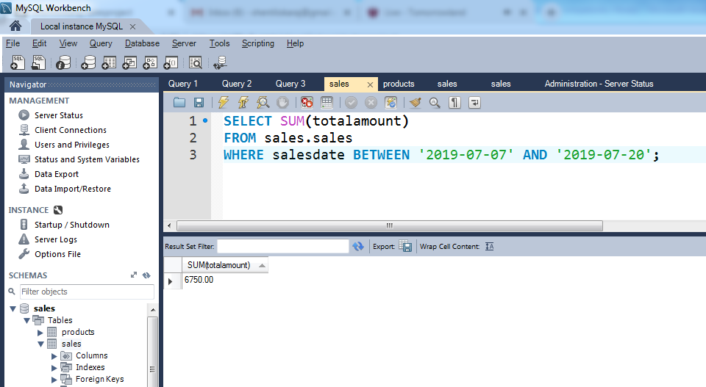

Test Case 8: Select date range for which the total amount of sales is 0.
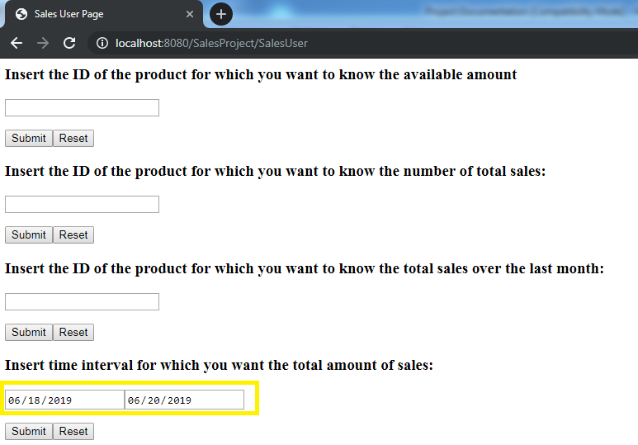

The correct output is shown below:

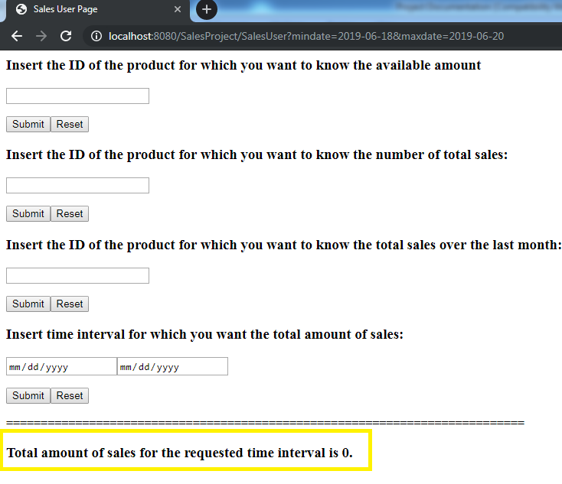

The correct result is matched to the one returned from a direct query in MySQL DB:
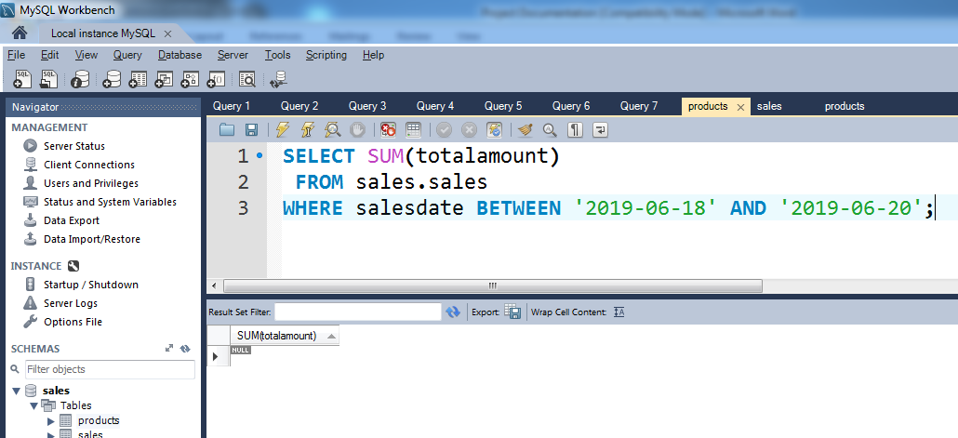

Bibliography

Oracle Corporation. (2017). Retrieved 7 10, 2019, from Java(TM) EE 8 Specification APIs: https://javaee.github.io/javaee-spec/javadocs/

Oracle Corporation. (2014). Distributed Multitiered Applications. Retrieved 7 15, 2019, from Oracle Java Documentation: https://docs.oracle.com/javaee/7/tutorial/overview003.htm#BNAAY

